|  |  |  |  |  |  |
| --- | --- | --- | --- | --- | --- |
| Date | 9-Dec-22 | | | Tester Name | Mayuri Patel |
| Environment | Penfax - Test | | | Login used |  |
| Operating System | Windows | Version: | Update: | | |
| Software Used | Edge | Version: | Update: | | |
| Not Applicable | Version: | Update: | | |
| Release version | 22.4.1 | | | | |
| Title | External Transfer In | | | | |
| Test Type | Regression | | | | |
| Test Scenario | Process a Leave of Absence Repayment (by RRSP) | | | | |
|  |  | | | | |
| Expected Results |  | | | | |
| Pass/Fail | Pass | | | JIRA# | N/A |

Describe your steps with screenshots:

1. Bring up the active member in PENFAX5. Open up a member.

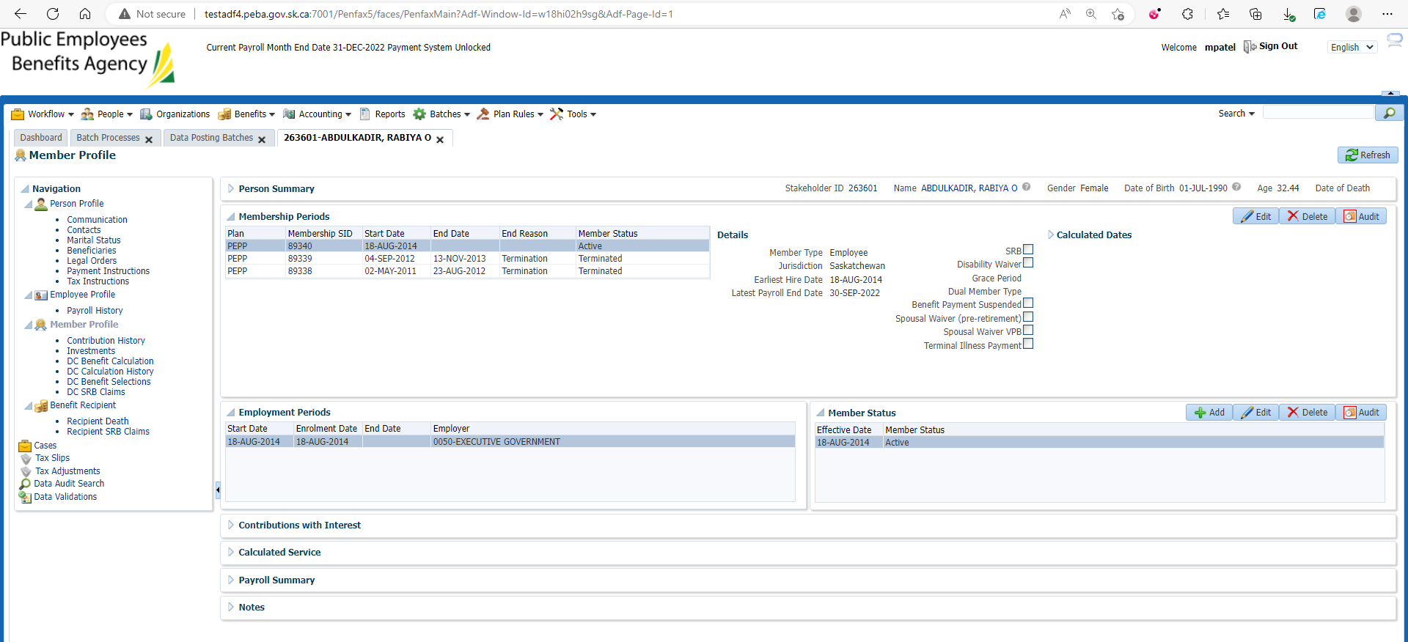

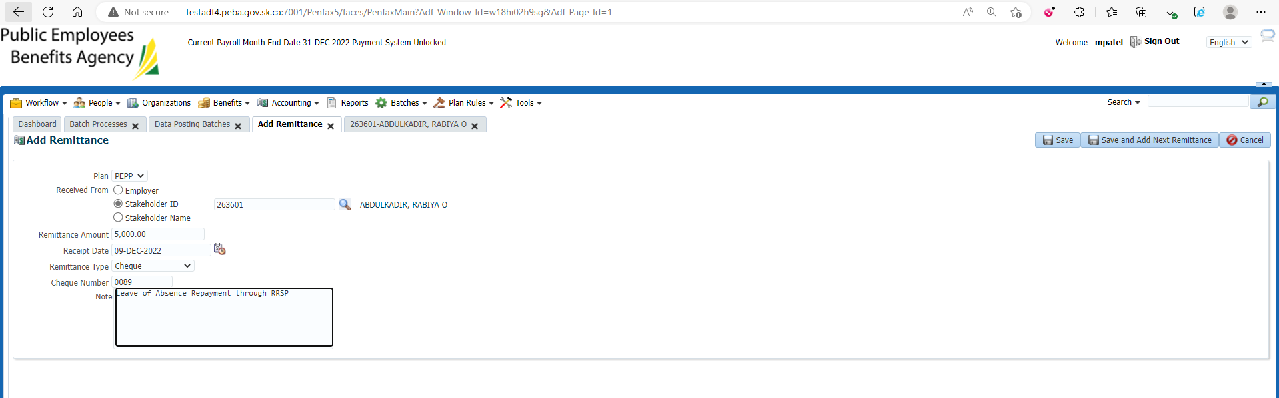

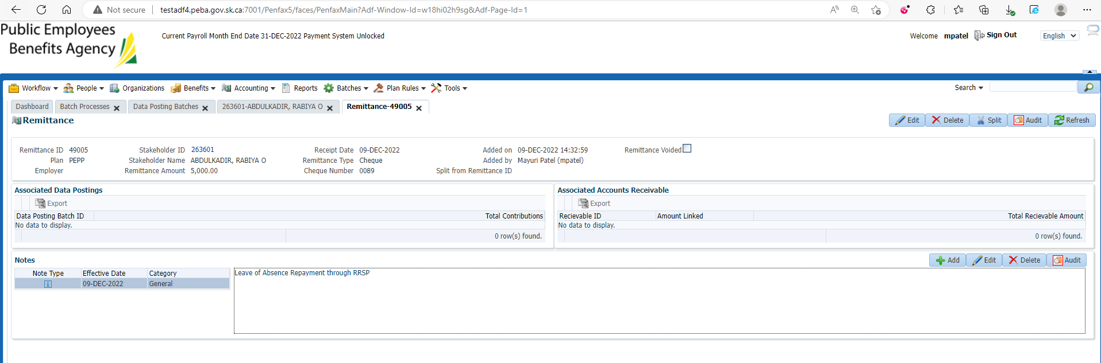

1. Go to DCT and Select the Employer that is for member in step 1
2. Create New File

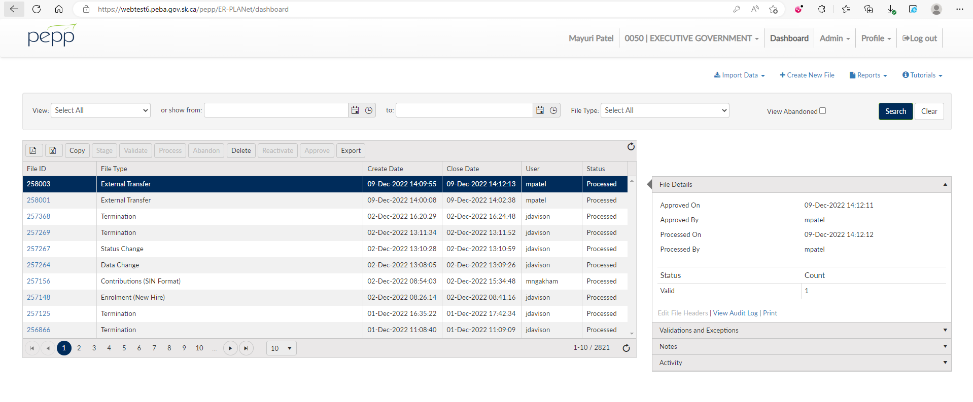

Select Leave of Absence Repayment through RRSP and Create

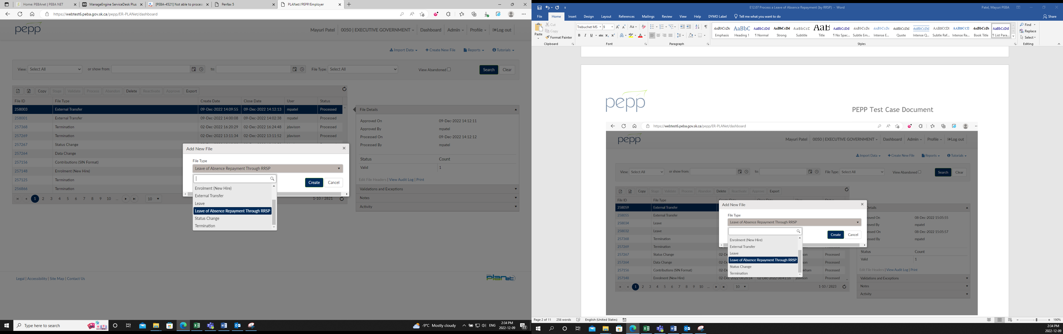

Enter Details and Save

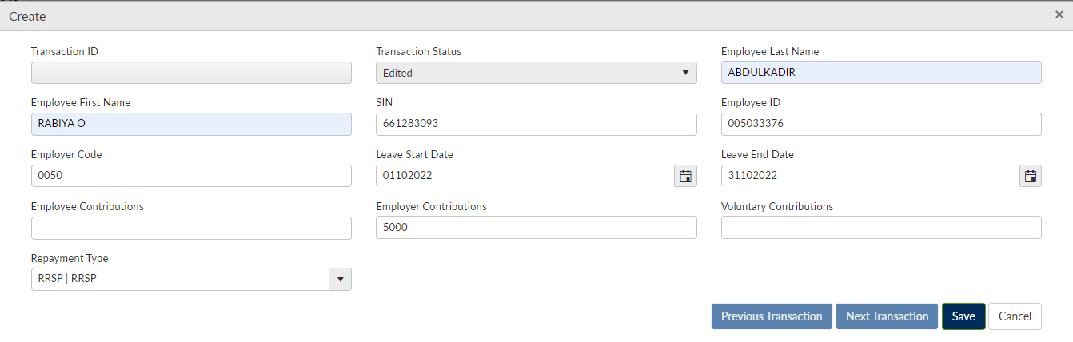

Validate, Approve and Process the file

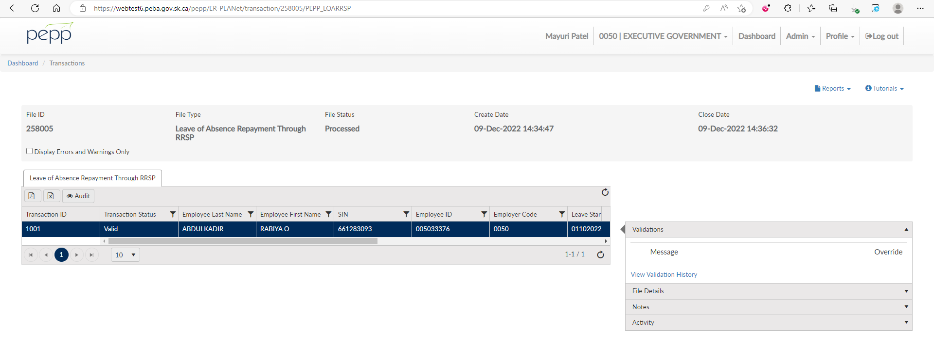

Go to Penfax and search for Data posting Batches

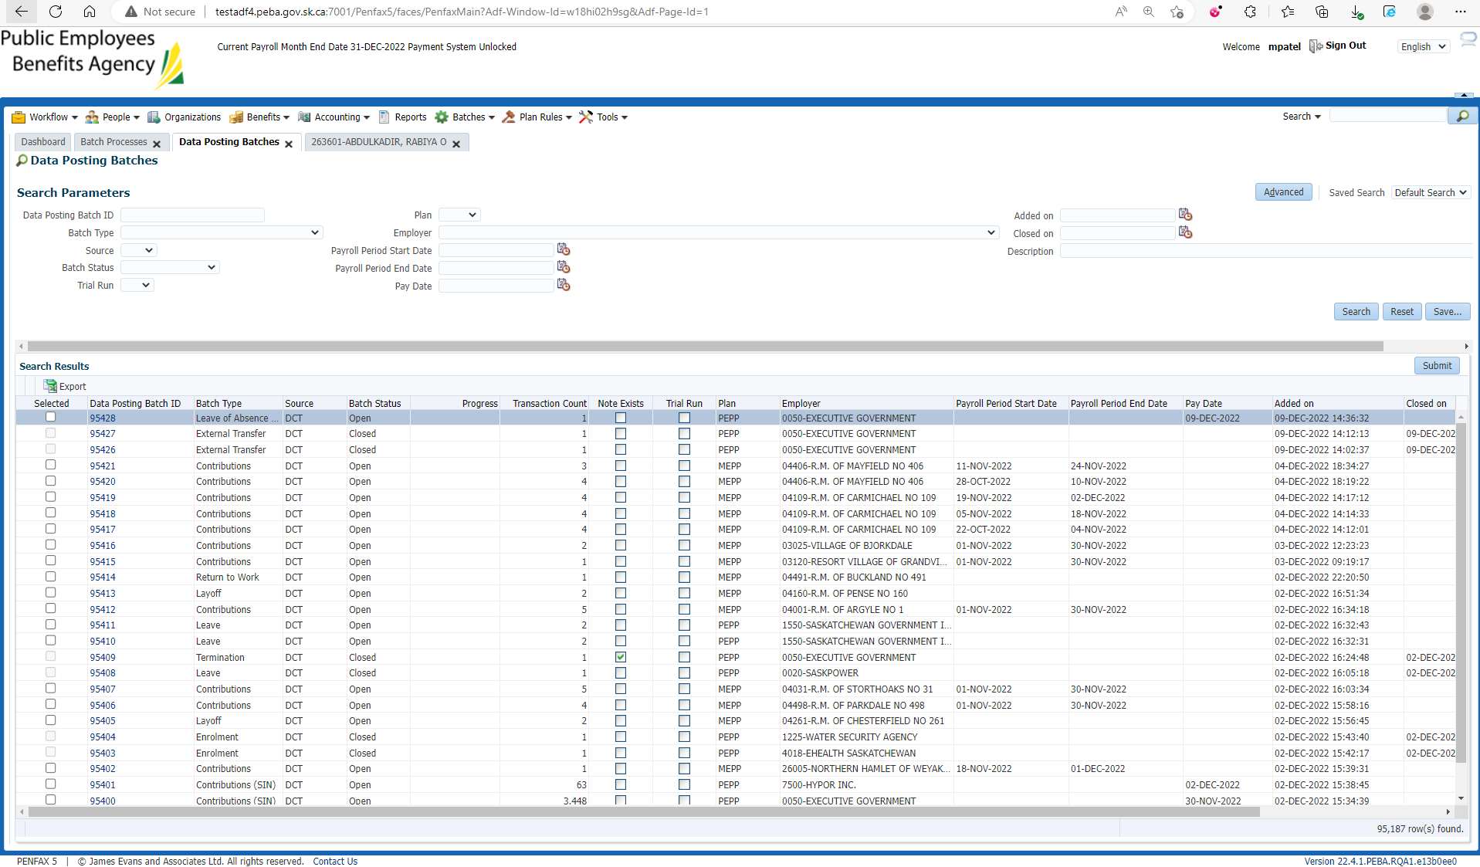

Open Leave of Absence Repayment Open Batch ID

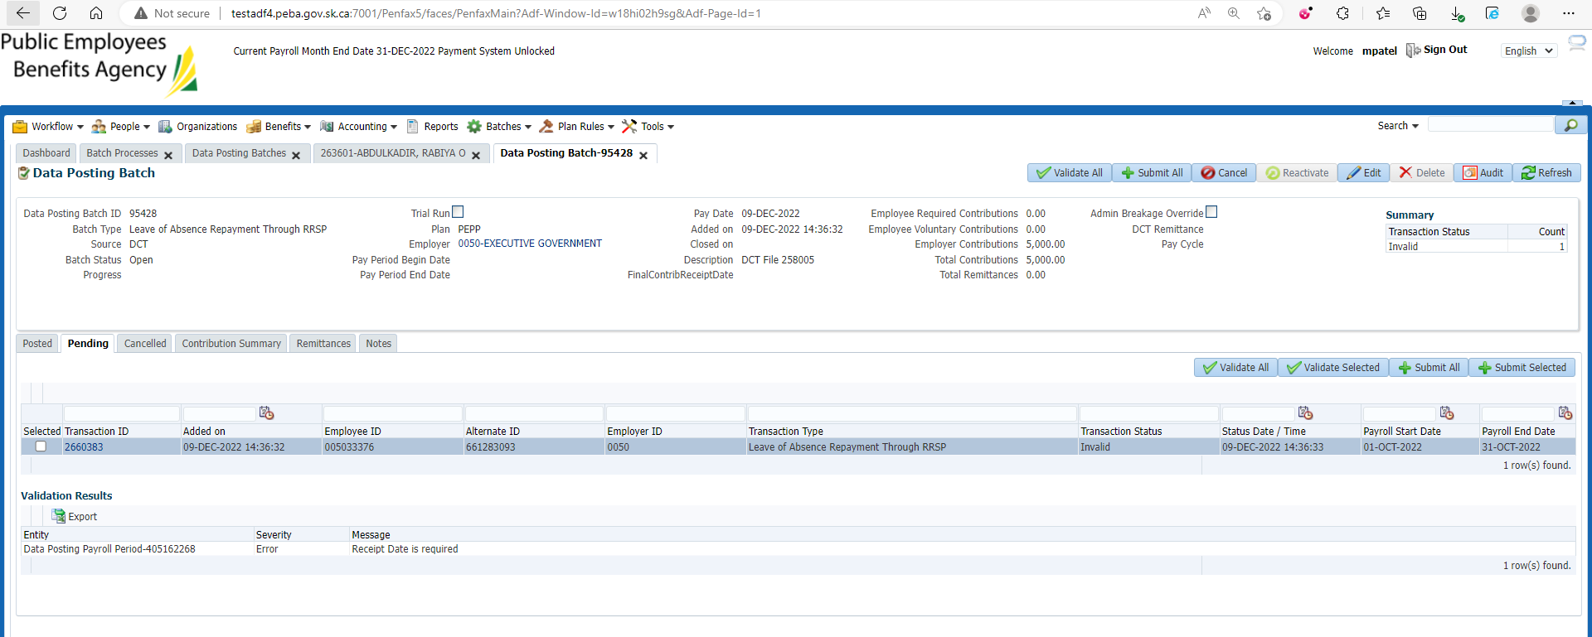

Add previously added remittance for the stakeholder under Remittances tab

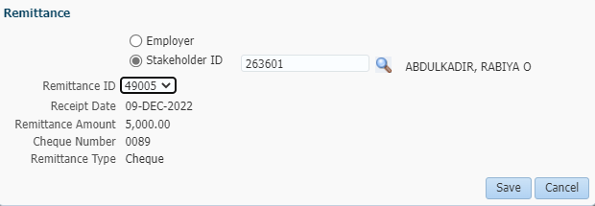

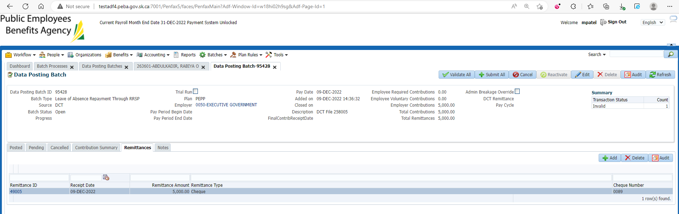

Validate and Submit Leave of Absence Repayment through RRSP pending File

Then it will be under posted tab

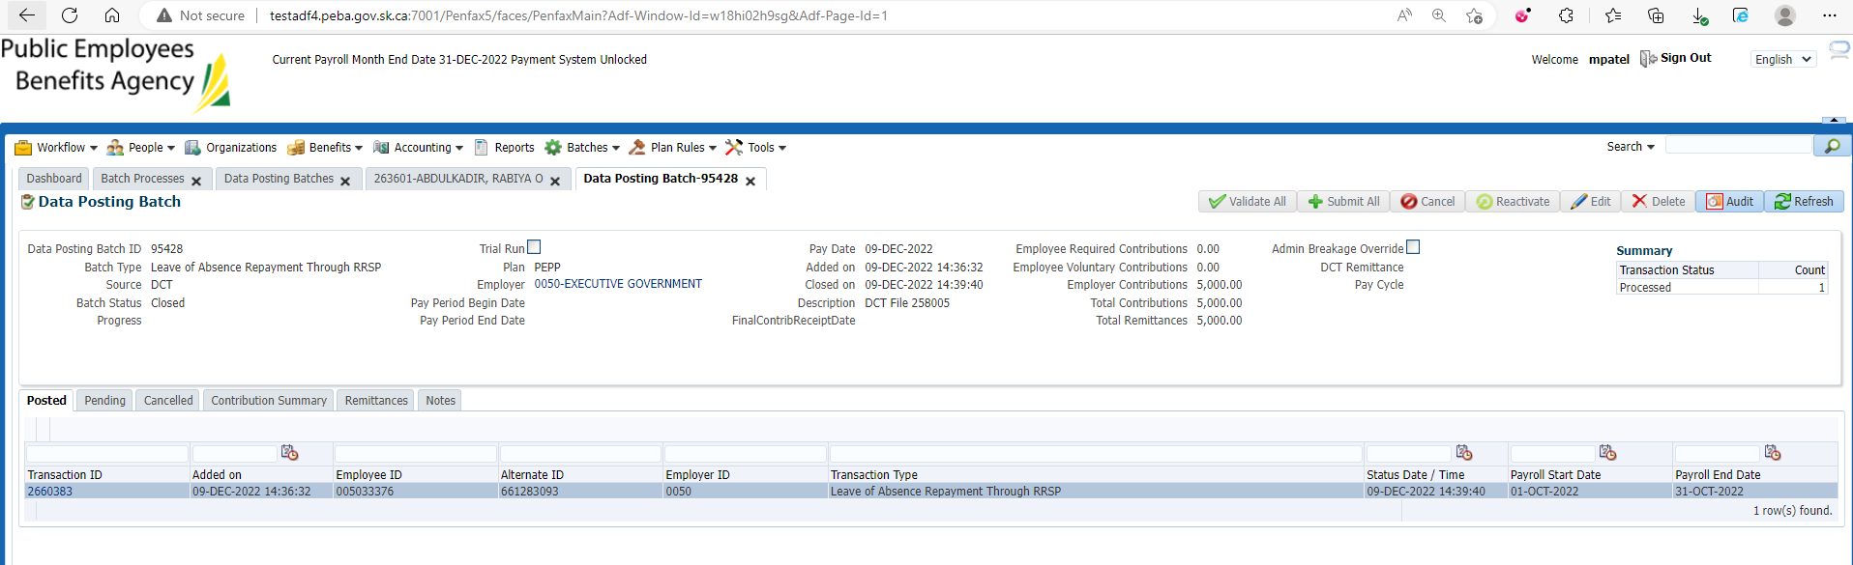

Under Contribution history

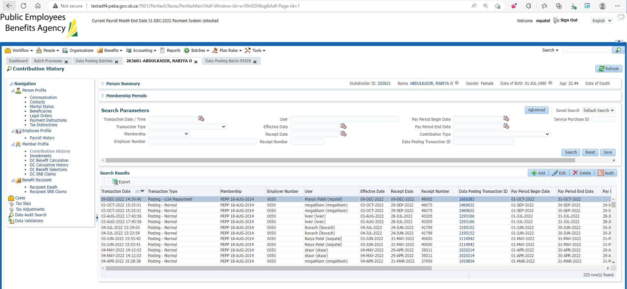

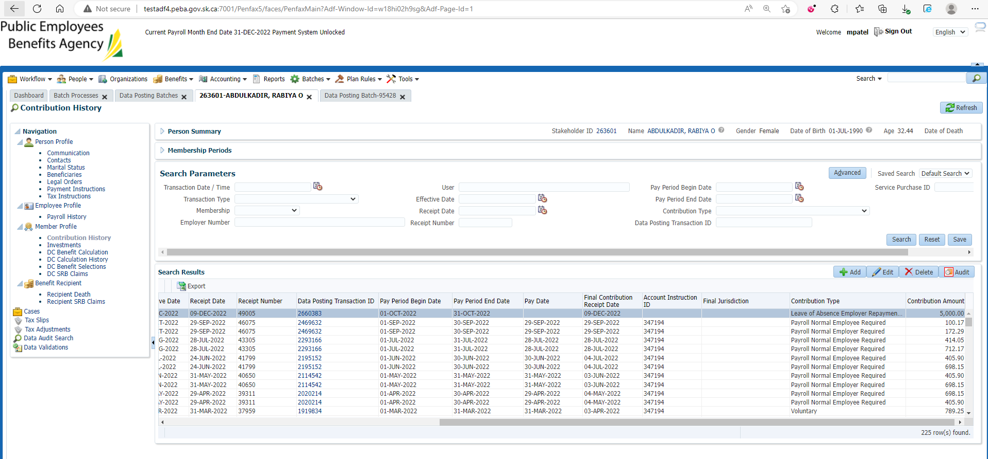

1. Wait for the next day, or process all the overnight batches to run.
2. Bring up the member again in PENFAX5. Go to the Investments Tab. Make sure the money shows up in the balance of the account. Also check the Deposit Allocation. Make sure the funds went into the correct account.

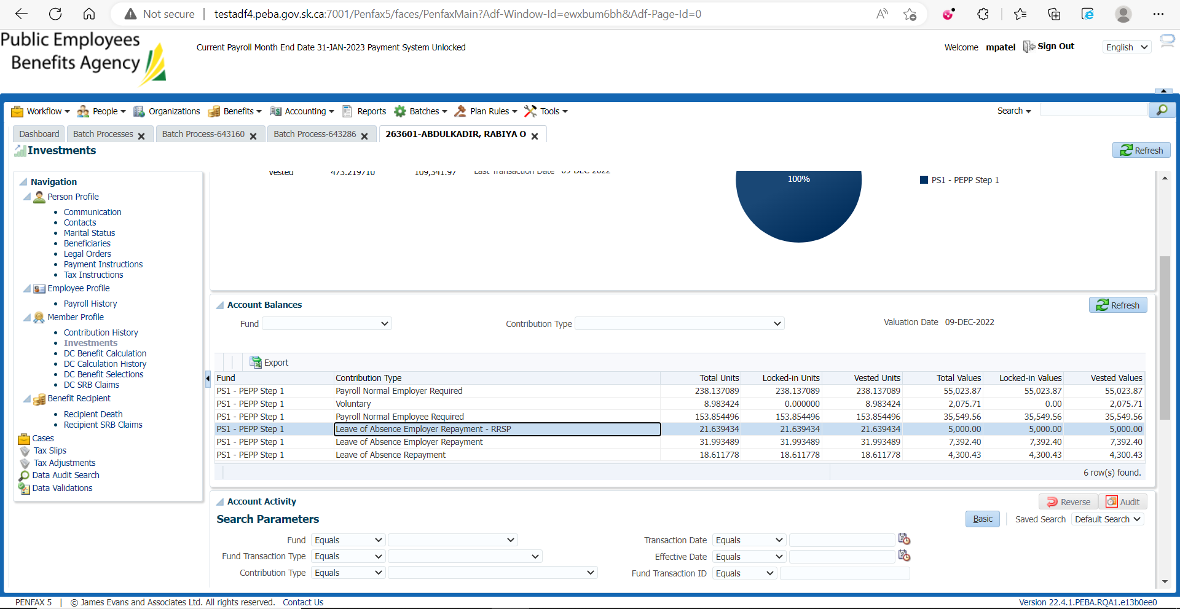

1. If you do a search under account activity it should show the transaction.

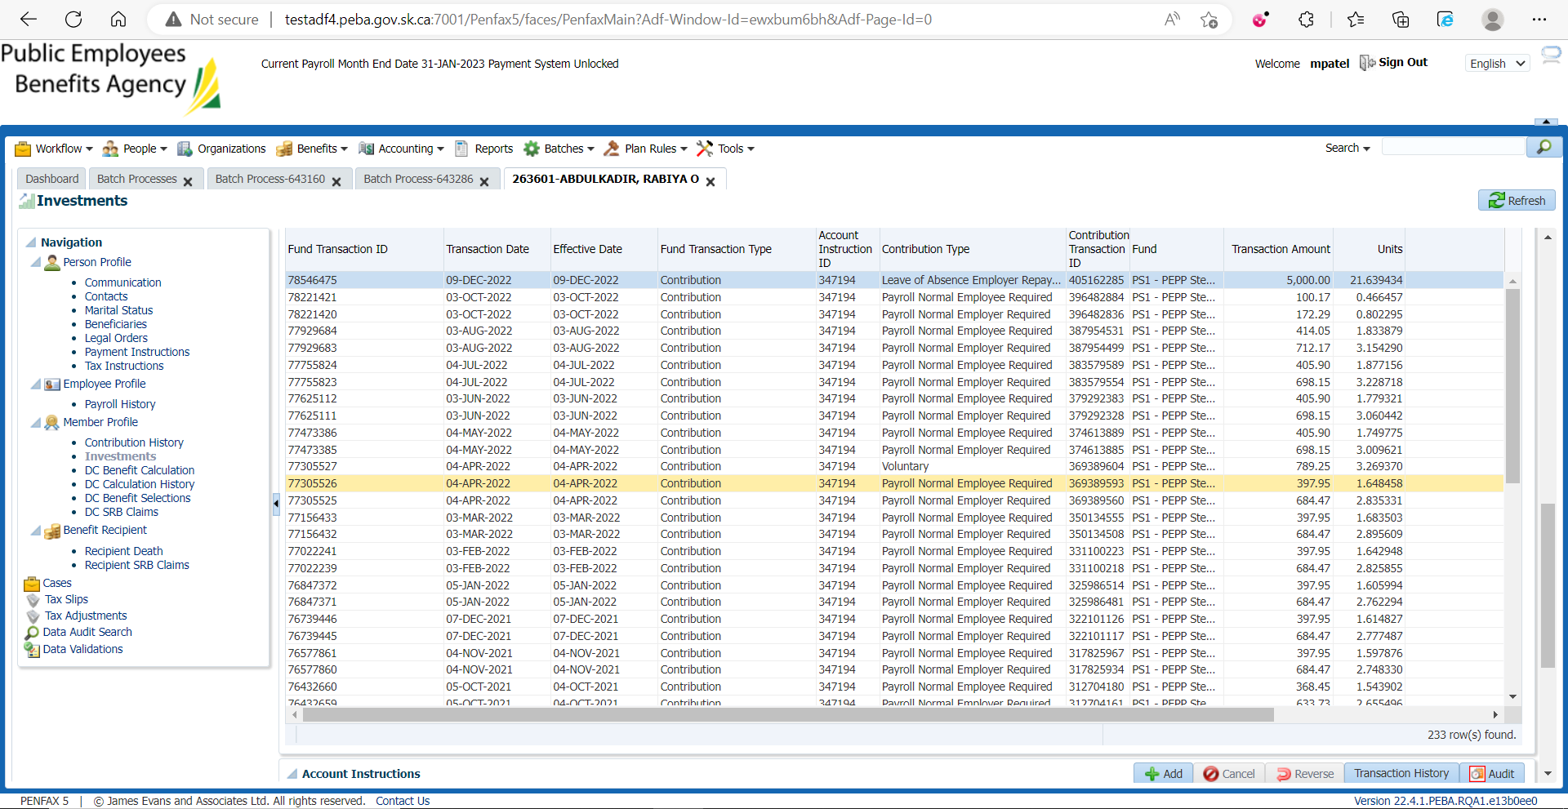

1. Go to the Communication tab. There should be a member deposit letter saved under Outbound Documents.

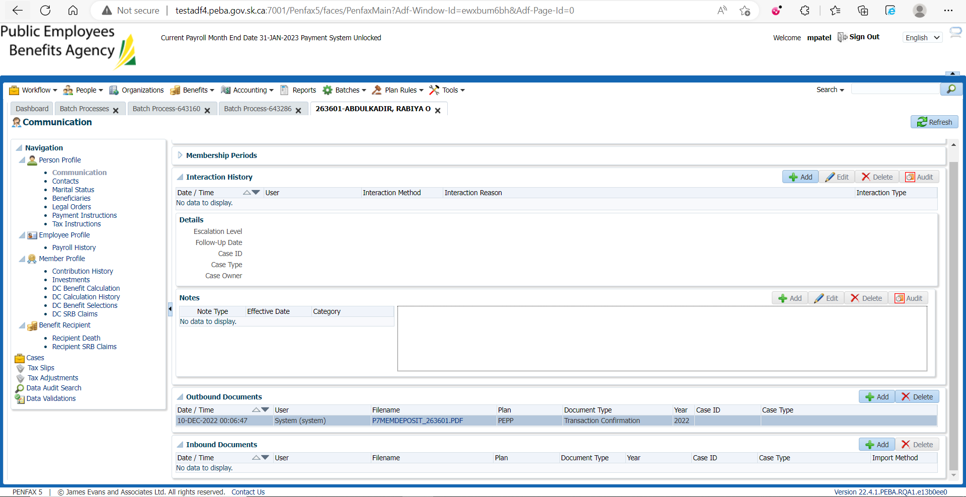

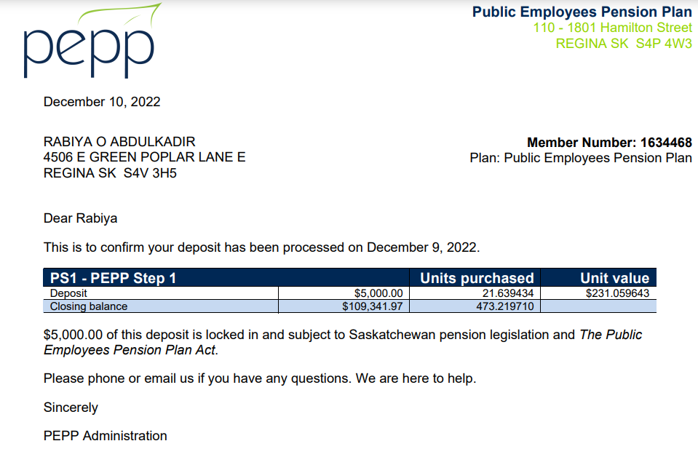

1. Go to Batches -> Batch Process -> Search for PEP Valuation Report.

On Section Two tab:

